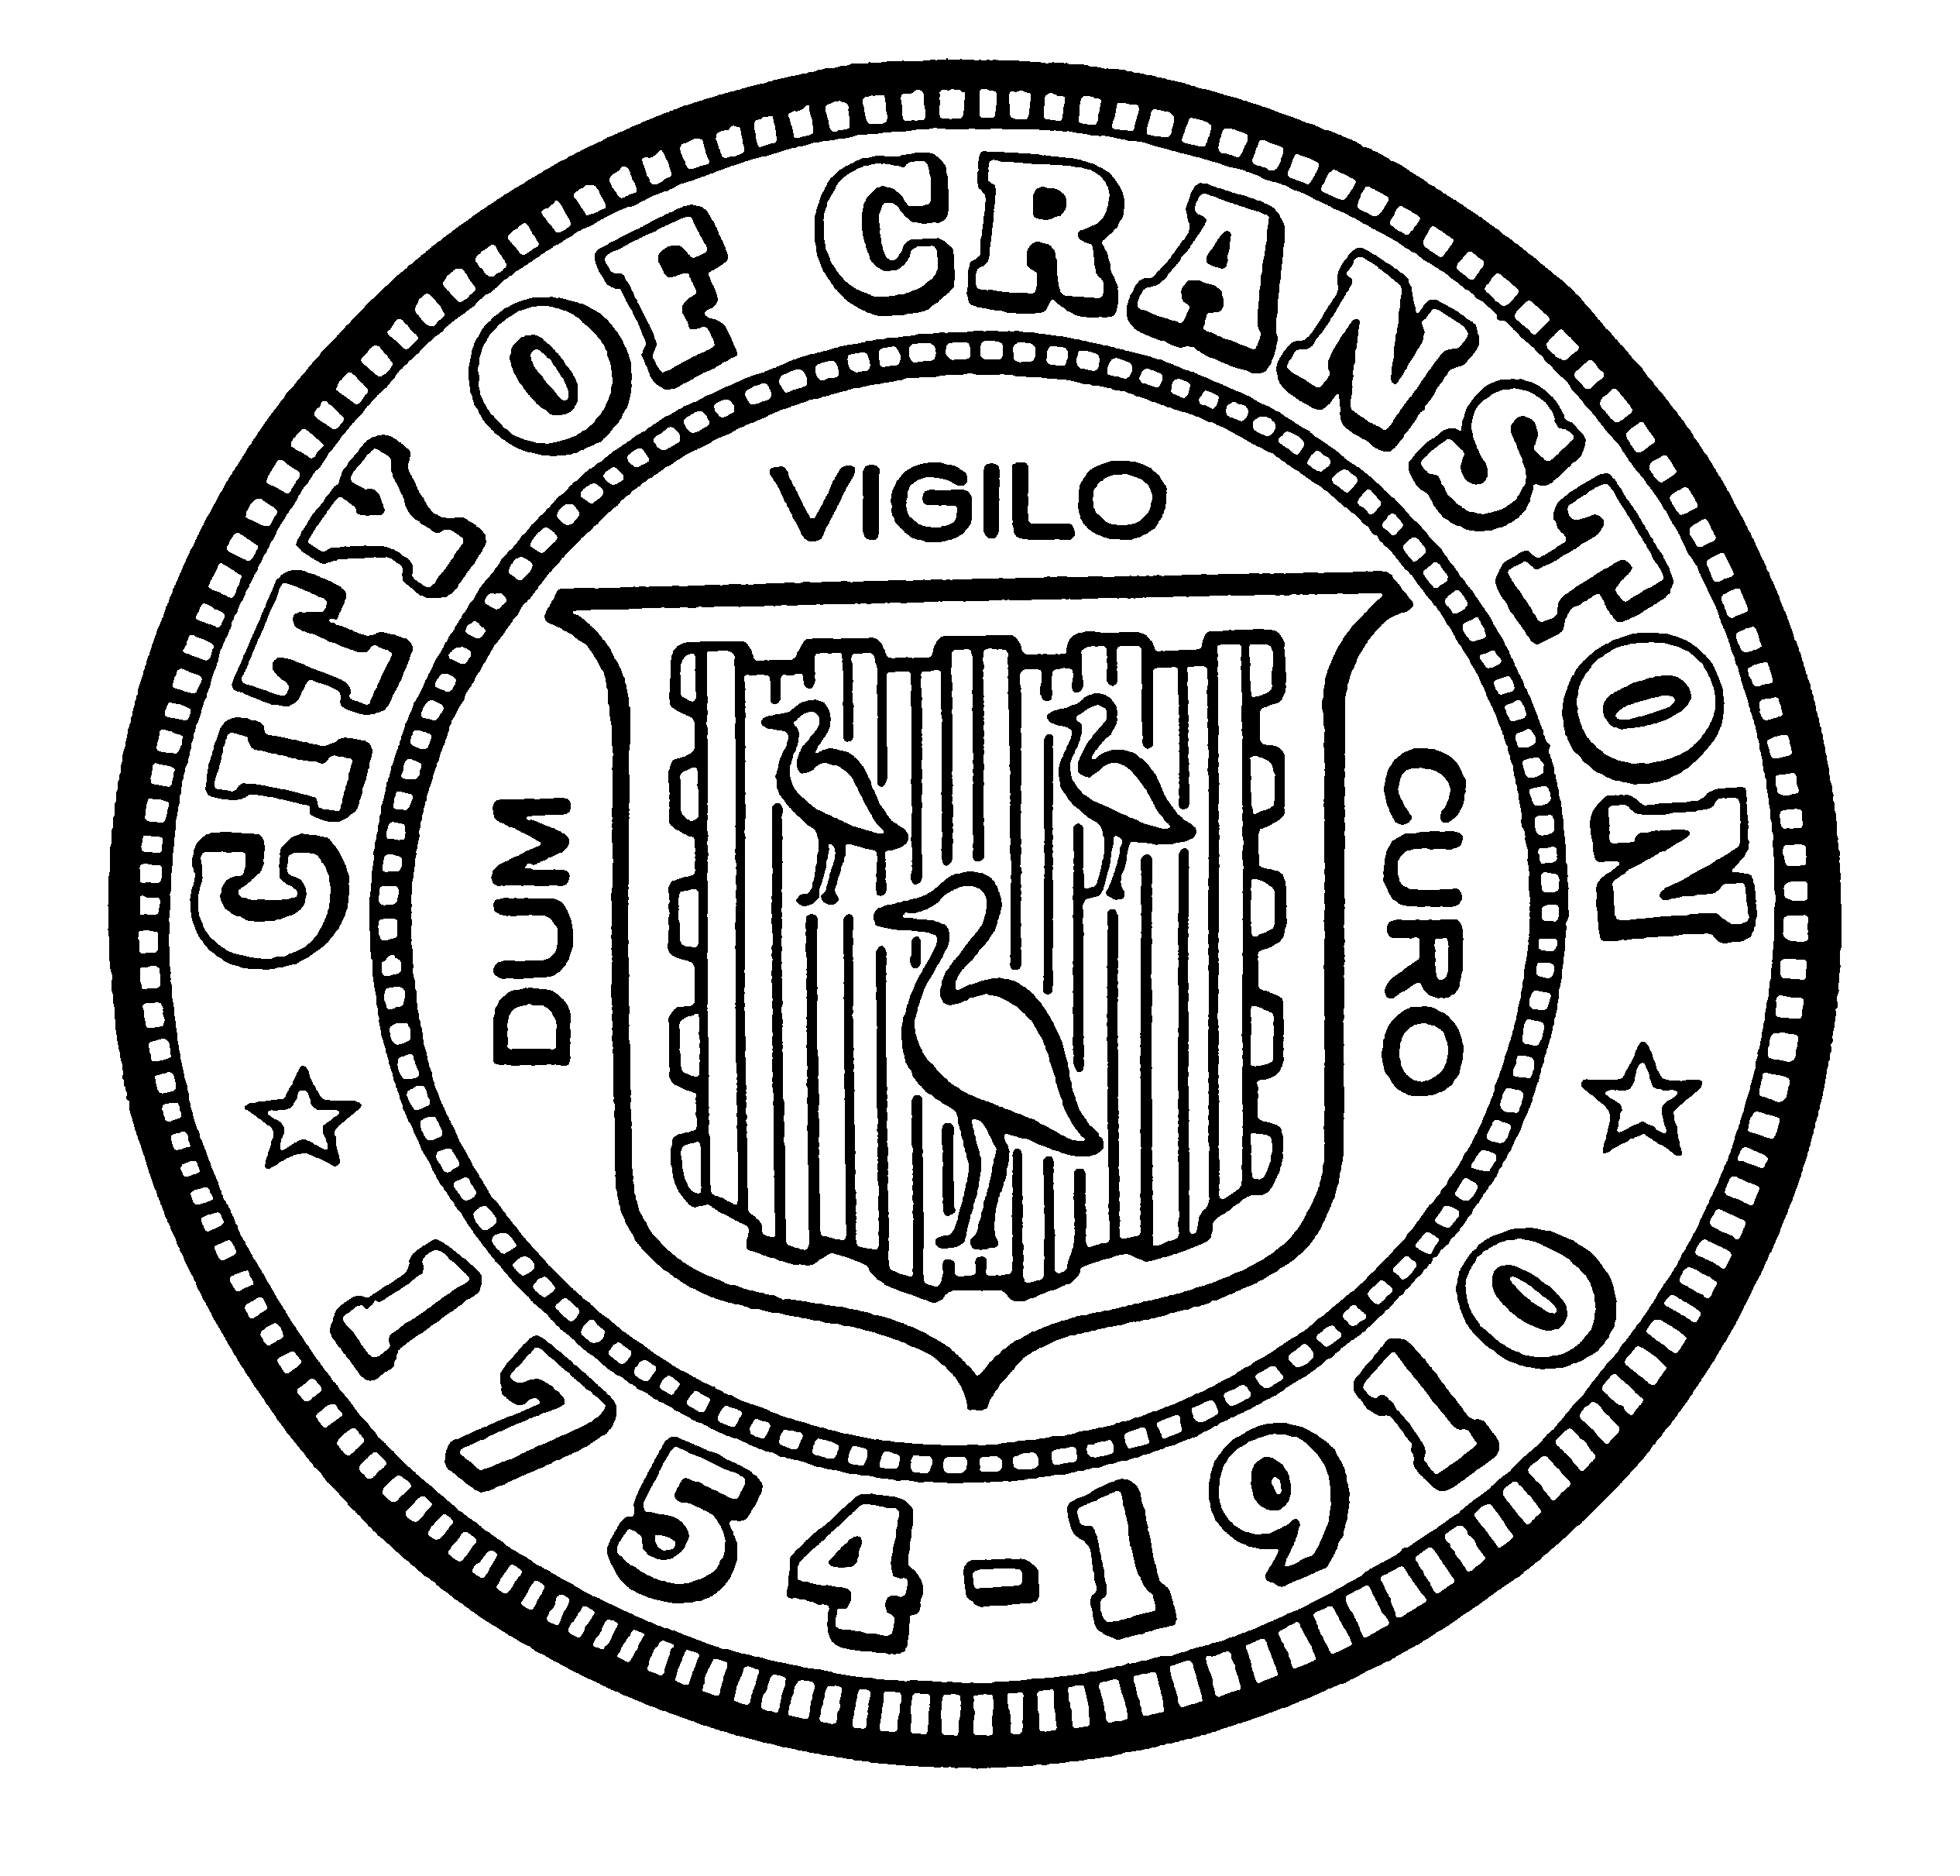

HOUSING COMMISSION

Annette Mann Bourne, Chair
Tim G. Sanzi, Community Development, Vice Chair
Amy Rainone, Secretary
Jason Case
Frank DiZoglio III
Joanne McGunagle, CCAP
Jason M. Pezzullo, Planning Director
Robert Santurri Jr, OneCranston Health Equity Zone
Derik Tutt

WEDNESDAY May 4, 2022 @ 5:30 P.M.
Cranston City Hall, 869 Park Avenue
3rd Floor Conference Room

MONTHLY MEETING- APRIL AGENDA

- Approval of minutes of April 6, 2022 meeting (for vote)
- Discussion of proposed comments on Certificate of Safe Occupancy ordinance (for vote)
- Discussion of presentation to the City Council (for discussion only)
- New business

“Individuals requesting interpreter services for the hearing-impaired must notify the Office of the City Clerk at 461-1000 Ext. 3197 seventy-two (72) hours in advance of the hearing date.”

